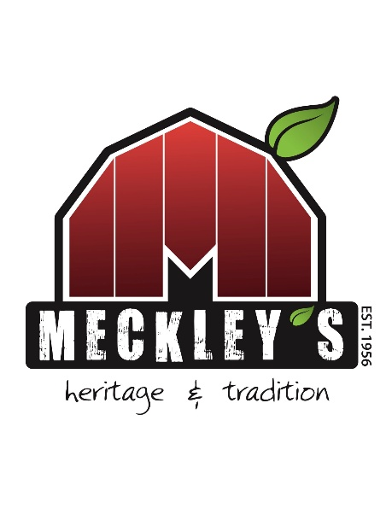
Meckley’s Flavor Fruit Farm
Donation Request Form

Please save a copy of this form after it has been filled out with the name of your company or organization. Email to meckleyevents@gmail.com
Thank you
Contact information for the person requesting the donation.
Name:
Address:
Phone Number:
Email:
Date of Request:
Date Donation is Due:

** DONATION REQUESTS MUST BE SUBMITTED AT LEAST TWO WEEKS PRIOR TO DONATION EVENT **
Who/What is the donation for?’

What type of donation are you looking for?

Who will benefit from this donation and how will the proceeds help them?

How will Meckley’s be recognized for the donation?

